**Unit 14 I remember meeting all of you in Grade 7.**

**Section A2 (3a-3c)**

**【学习目标】**

1．学习并掌握词汇：overcome，graduate，caring，ours，look back at，make a mess，keep one's cool

2．通过阅读诗歌“I Remember”，回忆美好的三年初中生活，激起最美好的记忆。

**【重点和难点】**

【学习重点】 阅读一首校园英文诗，讨论回答问题，语法总结。

【学习难点】 能够用自己的语言描述生活中难忘的经历。会总结自己的得失。

**【课前预习】**

**一、请根据中文意思写出下列重点单词。**

1. 克服；战胜*v.* _____

2. 毕业；获得学位*v.* _____

3．体贴人的；关心他人的*adj.* _____

4．我们的*pron.* _____

**二、请认真阅读课文，找出下列重点短语。**

5. 回首(往事)；回忆；回顾_____

6. 克服恐惧，自豪之情充满胸膛_____

7. 弄得一团糟(一塌糊涂) _____

8．沉住气；保持冷静_____

9．尽力赶上早读_____

**三、请用以上重点短语完成下列句子。**

10．回首过去三年，我记得许多事。

_____ _____ _____ _____ _____ _____ _____，I remember many things.

11．我在尽力保持冷静。

I'm trying to_____ _____ _____．

**四、根据句意和汉语提示完成单词。**

12. —What is the main s__________ of this writing?

—It is about the beginning of junior high school.

13. I think I can o_________ all kinds of problems till I succeed.

14. What are you going to be when you g _________ from junior high school?

15. We’ll miss our kind and__________ (关心他人的；体贴的) teachers.

16. These are your books. Those are __________ (我们的).

**【合作探究】**

**探究一、**Read the new words and phrases.

1．I can read. (我会读)

预习下列单词和短语，争取自己能正确拼读。拼读成功后再在课文中把单词和短语标记出来。

overcome，graduate，caring，ours，look back at，make a mess，keep one's cool

2．I can write.(我会写)

翻译下列短语：

1) 回首______

2) 克服恐惧，自豪之情充满胸膛______

3) 为……做准备______

4) 弄得一团糟______

5) 沉住气；保持冷静______

6) 尽力赶上早读______

3．I can summarize. (我会总结)

keep one's cool 沉住气；保持冷静。cool用作名词

如：“I must keep my cool，” she thought. “Losing my temper isn't going to help.”

与keep one's cool意思相似的有keep cool！保持冷静！

**探究二、**Read 3a and get the main idea of the passage.

**1**．**Fast reading.** (快速阅读)

快速阅读这篇文章，画出不明白的词组、句子。

**2**．**Intensive reading.** (精读)

Read the passage and answer the questions.

1) What kind of writing is this?

2) What is the main subject of this writing?

3) Who do you think the writer is?

3．I can retell. (我会复述)

你能写下文章的要点，并根据他们进行复述吗？

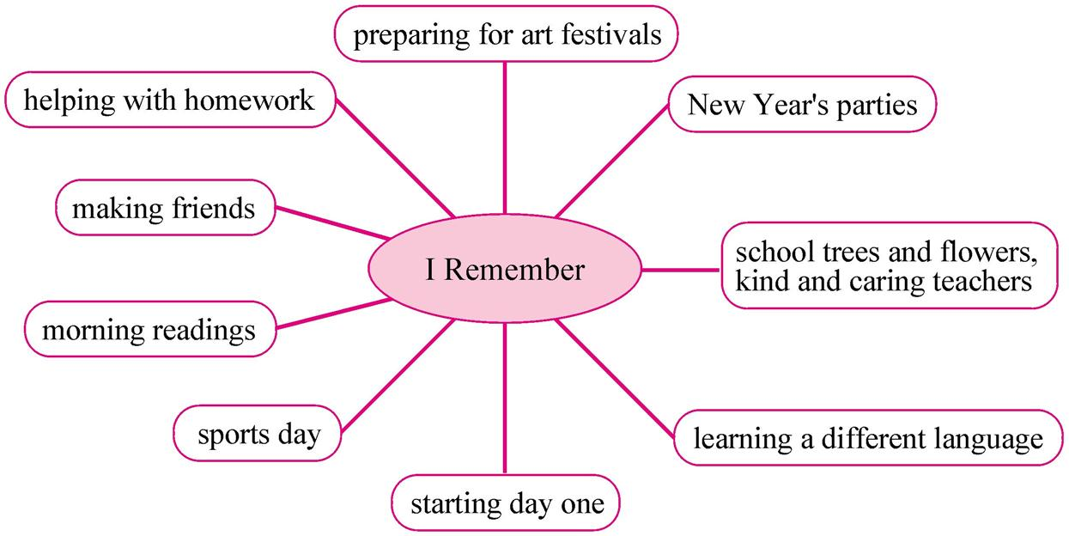

**探究三、**知识链接。

1．pride of overcoming fear克服恐惧，自豪之情充满胸膛

小小翻译官

为……感到自豪____

他们的女儿现在是一位著名的科学家，他们为她感到自豪。

They ____ ____ ____ their daughter，who is now a famous scientist.

2．preparing for art festivals为艺术节做准备

小小翻译官

prepare sth. 准备某物

prepare to do sth. 准备做某事

prepare sb. sth.＝prepare sth. for sb. 给某人准备某物

他正在准备明天会议要用的演说。

He is ____ ____ ____ for the meeting tomorrow.

我的妈妈常常为我们准备可口的早餐。

My mother often ____ ____ ____ ____．

＝My mother often ____ ____ ____ for us.

我们准备去度假。We ____ ____ ____ for a vacation.

3．And our kind and caring teacher和我们亲切友好和关心他人的老师

小小翻译官

关心 *n*． _________

细心的 *adj.* ________

关心他人的 *adj.* _________

粗心的*adj.* _________

细心地*adv.* _________

仔细 *n. ______*____

粗心地 *adv.* __________

粗心 *n.* __________

Mrs. White said that Mr. White is a ______ husband.

怀特太太说怀特先生是一位体贴的丈夫。

4. overcome

1) *vt.& vi.* 战胜，克服； 压倒，制服，……不堪

e.g. Find a way to overcome your difficulties. 找出办法战胜困难。

2) *vt.* 被（烟、感情等）熏[压]倒，使受不了

e.g. The residents were trying to escape from the fire but were overcome by smoke.

居民试图逃离火场，却被浓烟熏倒了。

3) *vi.* 受到……的极大影响

e.g. The night before the test I was overcome by fear and学科网(www.zxxk.com)--教育资源门户，提供试卷、教案、课件、论文、素材及各类教学资源下载，还有大量而丰富的教学相关资讯！ despair...

考试前的晚上，恐惧和绝望让我内心无比惊慌。

过去式： [overcame](http://www.iciba.com/overcame) 过去分词： overcome

现在分词： [overcoming](http://www.iciba.com/overcoming) 第三人称单数： overcomes

**【课时小结】**

重点单词

1. overcome *v.* 克服；战胜

2. graduate *v.* 毕业；获得学位

3. caring *adj.* 体贴人的；关心他人的

4. ours *pron.* 我们的

重点词组

1. look back at回首(往事)；回忆；回顾

2. pride of overcoming fear克服恐惧感的自豪

3. make a mess弄得一团糟(一塌糊涂)

4. keep one’s cool沉住气；保持冷静

5. try to be on time for morning reading尽力赶上早读

重点句式

1. Looking back at these past three years, I remember many things.

回首过去三年，我记得许多事。

2. And now it’s time to graduate. We will leave our lovely school.

现在毕业的时间到了，我们将要离开我们可爱的学校。

3. I’ll miss the school trees and flowers and our kind and caring teachers.

我会怀念学校的树木花草以及我们善良、体贴的老师。

**【达标检测】**

**一、单项选择。**

1. We should try _________ the poor people.

A. help B. to help C. helped D. in help

2. It’s important for the students_________ fear.

A. overcome B. overcame C. overcoming D. to overcome

3. Why did you __________ in your bedroom last night?

A. making a mess B. to make a mess

C. make a mess D. makes a mess

4. We want to keep_________ cool.

A. us B. we C. ours D. our

5. —Mothers are always kind and __________.

—So学科网(www.zxxk.com)--教育资源门户，提供试卷、教案、课件、论文、素材及各类教学资源下载，还有大量而丰富的教学相关资讯！ we should thank our mothers.

A. care B. to care C. cared D. caring

**二、用所给单词的适当形式填空。**

1. What kind of__________ (write) is this passage?

2. Lu Xun was a famous _________ (write).

3. You need to overcome some_________ (difficulty).

4. —Why are you in a hurry.

—I’ll try to be on time for morning ___________ (read).

5. English brings many________ (challenge) to everyone.

**三、根据所给汉语完成英语句子。**

1. 我能记起每一年运动会时的激动时刻。

I can remember the ________ ________ the school sports day each year.

2. 学生们需要需多长时间的训练。

The students need the many long __________ of _________.

3. 今年夏天我该初中毕业了。

It’s time _________ _________ from junior high school this summer.

4. 我正尽力保持冷静，但是我做不到。

I am trying t学科网(www.zxxk.com)--教育资源门户，提供试卷、教案、课件、论文、素材及各类教学资源下载，还有大量而丰富的教学相关资讯！o _________ _________ __________, but I can’t do it.

5. 我的英语老师是一名和蔼可亲、关心他人的老师。

My English teacher is a _________ and _________ teacher.

**四、句型转换。**

1. I always remember preparing for art festivals. (就画线部分提问)

________ ________ you always ________?

2. To help each other with homework is important. (改为同义句)

________ ________ ________ help each other with homework.

3. We remembered running to the dining hall when the lunch bell rang. (就画线部分提问)

_________ _________ you remember running when the lunch bell rang?

4. Remember to have breakfast in the morning. (改为同义句)

________ ________ to have breakfast in the morning.

5. All of the students have fun at New Year’s parties. (改为同义句)

All of the students ________ ________ ________ New Year’s parties.

**【自我评价】**

1. 本课我学会了什么？

____________________________________________________

2. 通过本课的学习，我还有哪些疑问？

____________________________________________________

**参考答案：**

【课前预习】

1. overcome
2. graduate
3. caring
4. ours
5. look back at
6. pride of overcoming fear
7. make a mess
8. keep one's cool
9. try to be on time for morning readings
10. Looking back at these past three years
11. keep my cool

12. subject

13. overcome

14. graduate

15. caring

16. ours

探究一

1. look back at
2. pride of overcoming fear
3. prepare for…
4. make a mess
5. keep my cool
6. try to be on time for morning readings

探究二

2.

1. This is a poem.
2. The main subject is the writer's memories of school over the last three years.
3. The writer is a student who is just about to graduate.

3.

The writer is looking back at these past three years: Trying to be on time for morning readings. Running to the dining hall when the lunch bell rings. Remembering the excitement. Of the school sports day proud when they overcame their fears. Remembering starting day. The shyest in my whole class. Remembering forever Helping each other with homework. Preparing for art festivals. Having fun at New Year’s parties. Learning a different language brings many challenges. We work hard to understand. And now it’s time to graduate. I’m trying to keep my cool. But it’s difficult not to cry. I’ll miss our kind and caring teachers.

探究三

1. be proud of; take pride in/are proud of
2. preparing his speech; prepares us nice breakfast; prepares nice breakfast; prepared to go
3. care; careful; caring; careless; carefully; carefulness ; carelessly; carelessness; caring

【达标检测】

一、BDCDD

二、1. writing 2. writer 3. difficulties 4. reading 5. challenges

三、1. excitement of 2.hours; training 3. to graduate

4. keep my cool 5. kind; caring

四、1. What do; remember 2. It is important 3. Where did

4. Don’t forget 5. enjoyed themselves